GURU TEGH BAHADUR INSTITUTE OF TECHNOLOGY


ADVANCED JAVA PROGRAMMING PRACTICAL FILE

SUBJECT CODE: CIE‐306T

SEMESTER – VI

Submitted to, Submitted by,
Dr. Amandeep Kaur Name: Abhay Raj
Enrolment No: 00976803122
Branch: IT – 3
Batch: 2022-2026

Index

S.No | Program | Date | Signature
1. | Write a program to demonstrate different types of inheritance.
2. | Write a program to show different types of exceptions.
3. | Write a program to create a scene using graphics class of Java applet.
4. | Write a program to create a Marquee using Java applet.
5. | Design a java program to implement producer consumer problem.
6. | Design a java program to implement reader writer problem.
7. | Design a java program to implement dining philosophers problem.
8. | WAP for a client to server communication.
9. | WAP to implement a server to client communication.
10. | WAP to implement a bidirectional communication.
11. | Write a program to create a URL object and display its properties.
12. | Write a program to implement opening of a URL Connection.
13. | Write a program to implement reading data from URL.
14. | Write a program to show using HttpURLConnection for sending HTTP requests.
15. | Write a program to Make an HTTP Post Request.
16. | WAP to read a file using HTTP URL Connection.
17. | Write a Java program to show user validation using servlet
18. | Write a Java program to set cookie Information using servlet.
19. | Write a Java program to insert data into a table using JSP.
20. | Write JSP program to implement form data validation.
21. | Write a Java program to demonstrate Remote Method Invocation (RMI) by creating a simple calculator application.

Program – 1

Aim: Write a program to demonstrate different types of inheritance.

Code:
class Animal {
void eat() {
System.out.println("This animal eats food.");
}
}

class Dog extends Animal {
void bark() {
System.out.println("The dog barks.");
}
}

class Vehicle {
void drive() {
System.out.println("The vehicle is driving.");
}
}

class Car extends Vehicle {
void honk() {
System.out.println("The car honks.");
}
}

class ElectricCar extends Car {
void charge() {
System.out.println("The electric car is charging.");
}
}

class Employee {
void work() {
System.out.println("The employee is working.");
}
}

class Manager extends Employee {
void manage() {
System.out.println("The manager is managing.");
}
}

class Developer extends Employee {
void code() {
System.out.println("The developer is coding.");
}
}
public class InheritanceDemo {
public static void main(String[] args) {
System.out.println("Single Inheritance:");
Dog dog = new Dog();
dog.eat();
dog.bark();
System.out.println();

System.out.println("Multilevel Inheritance:");
ElectricCar electricCar = new ElectricCar();
electricCar.drive();
electricCar.honk();
electricCar.charge();
System.out.println();

System.out.println("Hierarchical Inheritance:");
Manager manager = new Manager();
manager.work();
manager.manage();

Developer developer = new Developer();
developer.work();
developer.code();
System.out.println();
System.out.println("Name: Abhay Raj\nEnrolment No: 00976803122");
}
}

Output:

Single Inheritance:
This animal eats food.
The dog barks.

Multilevel Inheritance:
The vehicle is driving.
The car honks.
The electric car is charging.

Hierarchical Inheritance:
The employee is working.
The manager is managing.
The employee is working.
The developer is coding.

Name: Abhay Raj
Enrolment No: 00976803122
Program – 2

Aim: Write a program to show different types of exceptions.

Code:

class CustomException extends Exception {
public CustomException(String message) {
super(message);
}
}

public class ExceptionDemo {
public static void main(String[] args) {
try {
int result = 10 / 0;
} catch (ArithmeticException e) {
System.out.println("ArithmeticException: " + e.getMessage());
}

try {
String str = null;
System.out.println(str.length());
} catch (NullPointerException e) {
System.out.println("NullPointerException: " + e.getMessage());
}

try {
int[] arr = new int[2];
arr[5] = 10;
} catch (ArrayIndexOutOfBoundsException e) {
System.out.println("ArrayIndexOutOfBoundsException: " + e.getMessage());
}

try {
String str = "abc";
int num = Integer.parseInt(str);
} catch (NumberFormatException e) {
System.out.println("NumberFormatException: " + e.getMessage());
}

try {
throw new CustomException("This is a custom exception.");
} catch (CustomException e) {
System.out.println("CustomException: " + e.getMessage());
}
System.out.println("Name: Abhay Raj\nEnrolment No: 00976803122");
}
}

Output:

ArithmeticException: / by zero
NullPointerException: null
ArrayIndexOutOfBoundsException: 5
NumberFormatException: For input string: "abc"
CustomException: This is a custom exception.
Name: Abhay Raj
Enrolment No: 00976803122
Program – 3

Aim: Write a program to create a scene using graphics class of Java applet.

Code:

import java.applet.Applet;
import java.awt.Color;
import java.awt.Graphics;

public class SceneApplet extends Applet {
public void paint(Graphics g) {

setBackground(Color.cyan);

g.setColor(Color.yellow);
g.fillOval(50, 50, 100, 100);

g.setColor(Color.orange);
g.fillRect(200, 200, 200, 150);

g.setColor(Color.red);
int[] xPoints = {200, 400, 300};
int[] yPoints = {200, 200, 100};
g.fillPolygon(xPoints, yPoints, 3);

g.setColor(new Color(139, 69, 19));
g.fillRect(275, 275, 50, 75);

g.setColor(Color.white);
g.fillRect(230, 230, 40, 40);

g.setColor(new Color(139, 69, 19));
g.fillRect(500, 250, 30, 60);

g.setColor(Color.green);
g.fillOval(485, 200, 60, 60);
System.out.println("Name: Abhay Raj\nEnrolment No: 00976803122");
}
}
/*
<applet code="SceneApplet" width=600 height=400>
</applet>
*/

Output:

Name: Abhay Raj
Enrolment No: 00976803122

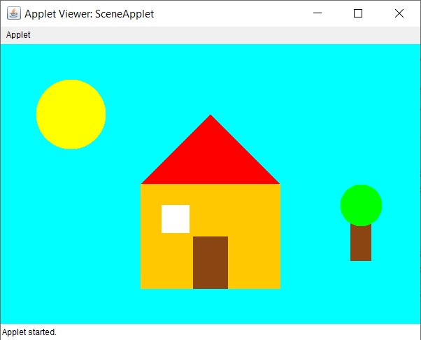
Program – 4

Aim: Write a program to create a Marquee using Java applet.

Code:

import java.applet.Applet;
import java.awt.Color;
import java.awt.Font;
import java.awt.Graphics;

public class MarqueeApplet extends Applet implements Runnable {
private String message = "Welcome to Java Applet Marquee!";
private int xPosition = 600; // Start position of the text
private Thread marqueeThread;

@Override
public void init() {
setBackground(Color.black);
setForeground(Color.white);
setFont(new Font("Arial", Font.BOLD, 30));

// Start the marquee thread
marqueeThread = new Thread(this);
marqueeThread.start();
}

@Override
public void run() {
while (true) {
// Move the text to the left
xPosition -= 2;

// If the text has completely moved off the screen, reset its position
if (xPosition < -getFontMetrics(getFont()).stringWidth(message)) {
xPosition = getWidth();
}

// Repaint the applet to update the position of the text
repaint();

try {
// Pause the thread for 50 milliseconds to control the speed of the scrolling
Thread.sleep(50);
} catch (InterruptedException e) {
e.printStackTrace();
}
}
}

@Override
public void paint(Graphics g) {
// Draw the message at the current x position
g.drawString(message, xPosition, 100);
}

@Override
public void stop() {
// Stop the thread when the applet is stopped
marqueeThread = null;
}
}
// <html>
// <body>
// <applet code="MarqueeApplet.class" width="600" height="200">
// </applet>
// </body>
// </html>

Output:

Name: Abhay Raj
Enrolment No: 00976803122

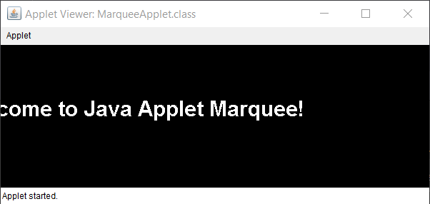
Program – 5

Aim: Design a java program to implement producer consumer problem.

Code:

import java.util.LinkedList;

public class Threadexample {
public static void main(String[] args)
throws InterruptedException
{
final PC pc = new PC();
System.out.println("Name: Abhay Raj\nEnrolment No: 00976803122");
Thread t1 = new Thread(new Runnable() {
@Override
public void run()
{
try {
pc.produce();
}
catch (InterruptedException e) {
e.printStackTrace();
}
}
});

Thread t2 = new Thread(new Runnable() {
@Override
public void run()
{
try {
pc.consume();
}
catch (InterruptedException e) {
e.printStackTrace();
}
}
});

t1.start();
t2.start();

t1.join();
t2.join();

}

public static class PC {

LinkedList<Integer> list = new LinkedList<>();
int capacity = 2;

public void produce() throws InterruptedException
{
int value = 0;
while (true) {
synchronized (this)
{

while (list.size() == capacity)
wait();

System.out.println("Producer produced-"
+ value);
list.add(value++);

notify();

Thread.sleep(1000);
}
}
}

// Function called by consumer thread
public void consume() throws InterruptedException
{
while (true) {
synchronized (this)
{
// consumer thread waits while list
// is empty
while (list.size() == 0)
wait();

int val = list.removeFirst();

System.out.println("Consumer consumed-"
+ val);

notify();

Thread.sleep(1000);
}
}
}
}
}

Output:

Name: Abhay Raj
Enrolment No: 00976803122
Producer produced-0
Producer produced-1
Consumer consumed-0
Consumer consumed-1
Producer produced-2
Producer produced-3
Consumer consumed-2
Consumer consumed-3
Producer produced-4
Producer produced-5
Consumer consumed-4
Program – 6

Aim: Design a java program to implement reader writer problem.

Code:

class SharedResource {
private int data = 0;
private int readers = 0;

public synchronized void read() throws InterruptedException {
while (readers == -1) {
wait();
}
readers++;
System.out.println("Reader reads: " + data);
readers--;
if (readers == 0) {
notifyAll();
}
}

public synchronized void write(int newData) throws InterruptedException {
while (readers > 0) {
wait();
}
readers = -1;
data = newData;
System.out.println("Writer writes: " + data);
readers = 0;
notifyAll();
}
}

class Reader extends Thread {
private SharedResource resource;

public Reader(SharedResource resource) {
this.resource = resource;
}

@Override
public void run() {
try {
resource.read();
} catch (InterruptedException e) {
e.printStackTrace();
}
}
}

class Writer extends Thread {
private SharedResource resource;

public Writer(SharedResource resource) {
this.resource = resource;
}

@Override
public void run() {
try {
resource.write(100);
} catch (InterruptedException e) {
e.printStackTrace();
}
}
}

public class ReaderWriterProblem {
public static void main(String[] args) {
SharedResource resource = new SharedResource();
Reader reader1 = new Reader(resource);
Reader reader2 = new Reader(resource);
Writer writer1 = new Writer(resource);

reader1.start();
reader2.start();
writer1.start();

System.out.println("Name: Abhay Raj\nEnrolment No: 00976803122");
}
}

Output:

Name: Abhay Raj
Enrolment No: 00976803122
Reader reads: 0
Reader reads: 0
Writer writes: 100
Program – 7

Aim: Design a java program to implement dining philosophers problem.

Code:

import java.util.concurrent.locks.Lock;
import java.util.concurrent.locks.ReentrantLock;

class Philosopher extends Thread {
private int id;
private Lock leftFork;
private Lock rightFork;

public Philosopher(int id, Lock leftFork, Lock rightFork) {
this.id = id;
this.leftFork = leftFork;
this.rightFork = rightFork;
}

public void run() {
try {
while (true) {
think();
pickUpForks();
eat();
putDownForks();
}
} catch (InterruptedException e) {
e.printStackTrace();
}
}

private void think() throws InterruptedException {
System.out.println("Philosopher " + id + " is thinking.");
Thread.sleep((long) (Math.random() * 1000));
}

private void pickUpForks() throws InterruptedException {
leftFork.lock();
System.out.println("Philosopher " + id + " picked up left fork.");
rightFork.lock();
System.out.println("Philosopher " + id + " picked up right fork.");
}

private void eat() throws InterruptedException {
System.out.println("Philosopher " + id + " is eating.");
Thread.sleep((long) (Math.random() * 1000));
}

private void putDownForks() {
leftFork.unlock();
System.out.println("Philosopher " + id + " put down left fork.");
rightFork.unlock();
System.out.println("Philosopher " + id + " put down right fork.");
}
}

public class DiningPhilosophers {
public static void main(String[] args) {
int n = 5;
Lock[] forks = new Lock[n];

System.out.println("Name: Abhay Raj\nEnrolment No: 00976803122");

for (int i = 0; i < n; i++) {
forks[i] = new ReentrantLock();
}

Philosopher[] philosophers = new Philosopher[n];
for (int i = 0; i < n; i++) {
philosophers[i] = new Philosopher(i, forks[i], forks[(i + 1) % n]);
philosophers[i].start();
}
}
}

Output:

Name: Abhay Raj
Enrolment No: 00976803122
Philosopher 0 is thinking.
Philosopher 4 is thinking.
Philosopher 3 is thinking.
Philosopher 2 is thinking.
Philosopher 1 is thinking.
Philosopher 3 picked up left fork.
Philosopher 3 picked up right fork.
Philosopher 3 is eating.
Philosopher 2 picked up left fork.
Philosopher 0 picked up left fork.
Philosopher 0 picked up right fork.
Philosopher 0 is eating.
Philosopher 0 put down left fork.
Philosopher 0 put down right fork.
Philosopher 0 is thinking.
Program – 8

Aim: Write a program for a client to server communication.

Code (Client.java):

import java.io.*;
import java.net.*;

public class Client {
public static void main(String[] args) {
try (Socket socket = new Socket("localhost", 1234)) {
PrintWriter output = new PrintWriter(socket.getOutputStream(), true);
BufferedReader input = new BufferedReader(new InputStreamReader(socket.getInputStream()));

String message = "Hello, Server!";
output.println(message);
System.out.println("Client: " + message);

String serverResponse = input.readLine();
System.out.println(serverResponse);

socket.close();
System.out.println("Name: Abhay Raj\nEnrolment No: 00976803122");
} catch (IOException e) {
e.printStackTrace();
}
}
}

Code (Server.java)

import java.io.*;
import java.net.*;

public class Server {
public static void main(String[] args) {
try (ServerSocket serverSocket = new ServerSocket(1234)) {
System.out.println("Server is waiting for client connection...");
Socket clientSocket = serverSocket.accept();
System.out.println("Client connected!");

BufferedReader input = new BufferedReader(new InputStreamReader(clientSocket.getInputStream()));
PrintWriter output = new PrintWriter(clientSocket.getOutputStream(), true);

String clientMessage = input.readLine();
System.out.println("Client: " + clientMessage);

String response = "Server: Hello, Client!";
output.println(response);

clientSocket.close();
System.out.println("Name: Abhay Raj\nEnrolment No: 00976803122");
} catch (IOException e) {
e.printStackTrace();
}
}
}

Output (Client.java):

Client: Hello, Server!
Server: Hello, Client!
Name: Abhay Raj
Enrolment No: 00976803122

Output (Server.java):

Server is waiting for client connection...
Client connected!
Client: Hello, Server!
Name: Abhay Raj
Enrolment No: 00976803122
Program – 9

Aim: Write a program to implement a server to client communication.

Code (Client.java):

import java.io.*;
import java.net.*;

public class Client {
public static void main(String[] args) {
try (Socket socket = new Socket("localhost", 1234)) {
BufferedReader input = new BufferedReader(new InputStreamReader(socket.getInputStream()));

String serverMessage = input.readLine();
System.out.println("Client received: " + serverMessage);

socket.close();
System.out.println("Name: Abhay Raj\nEnrolment No: 00976803122");
} catch (IOException e) {
e.printStackTrace();
}
}
}

Code (Server.java):

import java.io.*;
import java.net.*;

public class Server {
public static void main(String[] args) {
try (ServerSocket serverSocket = new ServerSocket(1234)) {
System.out.println("Server is waiting for client connection...");
Socket clientSocket = serverSocket.accept();
System.out.println("Client connected!");

PrintWriter output = new PrintWriter(clientSocket.getOutputStream(), true);
String serverMessage = "Hello from Server!";
output.println(serverMessage);
System.out.println("Server sent: " + serverMessage);
clientSocket.close();
System.out.println("Name: Abhay Raj\nEnrolment No: 00976803122");
} catch (IOException e) {
e.printStackTrace();
}
}
}

Output (Client.java):

Client received: Hello from Server!
Name: Abhay Raj
Enrolment No: 00976803122

Output (Server.java):

Server is waiting for client connection...
Client connected!
Client: Hello, Server!
Name: Abhay Raj
Enrolment No: 00976803122
Program – 10

Aim: Write a program to implement a bidirectional communication.

Code (Client.java):

import java.io.*;
import java.net.*;

public class Client {
public static void main(String[] args) {
try (Socket socket = new Socket("localhost", 1234)) {
BufferedReader input = new BufferedReader(new InputStreamReader(socket.getInputStream()));
PrintWriter output = new PrintWriter(socket.getOutputStream(), true);

String clientMessage = "Hello from Client!";
output.println(clientMessage);
System.out.println("Sent to Server: " + clientMessage);

String serverResponse = input.readLine();
System.out.println("Received from Server: " + serverResponse);
System.out.println("Name: Abhay Raj\nEnrolment No: 00976803122");
socket.close();
} catch (IOException e) {
e.printStackTrace();
}
}
}

Code (Server.java):

import java.io.*;
import java.net.*;

public class Server {
public static void main(String[] args) {
try (ServerSocket serverSocket = new ServerSocket(1234)) {
System.out.println("Server is waiting for client connection...");
Socket clientSocket = serverSocket.accept();
System.out.println("Client connected!");

BufferedReader input = new BufferedReader(new InputStreamReader(clientSocket.getInputStream()));
PrintWriter output = new PrintWriter(clientSocket.getOutputStream(), true);

String clientMessage = input.readLine();
System.out.println("Received from Client: " + clientMessage);

String serverResponse = "Hello from Server!";
output.println(serverResponse);
System.out.println("Sent to Client: " + serverResponse);
System.out.println("Name: Abhay Raj\nEnrolment No: 00976803122");
clientSocket.close();
} catch (IOException e) {
e.printStackTrace();
}
}
}

Output (Client.java):

Sent to Server: Hello from Client!
Received from Server: Hello from Server!
Name: Abhay Raj
Enrolment No: 00976803122

Output (Server.java):

Server is waiting for client connection...
Client connected!
Client: Hello, Server!
Name: Abhay Raj
Enrolment No: 00976803122
Program – 11

Aim: Write a program to create a URL object and display its properties.

Code:

import java.net.URL;

public class URLExample {
public static void main(String[] args) {
try {
URL url = new URL("https://www.example.com:8080/path/to/resource?query=example#fragment");
System.out.println("Protocol: " + url.getProtocol());
System.out.println("Host: " + url.getHost());
System.out.println("Port: " + url.getPort());
System.out.println("Path: " + url.getPath());
System.out.println("Query: " + url.getQuery());
System.out.println("File: " + url.getFile());
System.out.println("Ref: " + url.getRef());
System.out.println("Authority: " + url.getAuthority());
System.out.println("Default Port: " + url.getDefaultPort());
System.out.println("Name: Abhay Raj\nEnrolment No: 00976803122");
} catch (Exception e) {
e.printStackTrace();
}
}
}

Output:

Protocol: https
Host: www.example.com
Port: 8080
Path: /path/to/resource
Query: query=example
File: /path/to/resource?query=example
Ref: fragment
Authority: www.example.com:8080
Default Port: 443
Name: Abhay Raj
Enrolment No: 00976803122
Program – 12

Aim: Write a program to implement opening of a URL Connection.

Code:

import java.io.*;
import java.net.HttpURLConnection;
import java.net.URL;

public class URLConnectionExample {
public static void main(String[] args) {
try {
URL url = new URL("https://www.example.com");
HttpURLConnection connection = (HttpURLConnection) url.openConnection();

connection.setRequestMethod("GET");
connection.setConnectTimeout(5000); // Set timeout to 5 seconds
connection.setReadTimeout(5000); // Set read timeout to 5 seconds

int responseCode = connection.getResponseCode();
System.out.println("Response Code: " + responseCode);

if (responseCode == HttpURLConnection.HTTP_OK) {
BufferedReader in = new BufferedReader(new InputStreamReader(connection.getInputStream()));
String inputLine;
StringBuffer response = new StringBuffer();

while ((inputLine = in.readLine()) != null) {
response.append(inputLine);
}
in.close();

System.out.println("Response Content: " + response.toString());
} else {
System.out.println("Failed to open connection.");
}

connection.disconnect();
System.out.println("Name: Abhay Raj\nEnrolment No: 00976803122");
} catch (IOException e) {
e.printStackTrace();
}
}
}

Output:

Response Code: 200
Response Content: <!doctype html><html><head> <title>Example Domain</title> <meta charset="utf-8" /> <meta http-equiv="Content-type" content="text/html; charset=utf-8" /> <meta name="viewport" content="width=device-width, initial-scale=1" /> <style type="text/css"> body { background-color: #f0f0f2; margin: 0; padding: 0; font-family: -apple-system, system-ui, BlinkMacSystemFont, "Segoe UI", "Open Sans", "Helvetica Neue", Helvetica, Arial, sans-serif; } div { width: 600px; margin: 5em auto; padding: 2em;
background-color: #fdfdff; border-radius: 0.5em; box-shadow: 2px 3px 7px 2px rgba(0,0,0,0.02);
} a:link, a:visited { color: #38488f; text-decoration: none; } @media (max-width: 700px) {
div { margin: 0 auto; width: auto; } } </style> </head><body><div> <h1>Example Domain</h1> <p>This domain is for use in illustrative examples in documents. You may use this domain in literature without prior coordination or asking for permission.</p> <p><a href="https://www.iana.org/domains/example">More information...</a></p></div></body></html>
Name: Abhay Raj
Enrolment No: 00976803122
Program – 13

Aim: Write a program to implement reading data from URL

Code:

import java.io.*;
import java.net.URL;
import java.net.HttpURLConnection;

public class ReadDataFromURL {
public static void main(String[] args) {
try {
URL url = new URL("https://www.example.com");
HttpURLConnection connection = (HttpURLConnection) url.openConnection();

connection.setRequestMethod("GET");
connection.setConnectTimeout(5000);
connection.setReadTimeout(5000);

int responseCode = connection.getResponseCode();
System.out.println("Response Code: " + responseCode);

if (responseCode == HttpURLConnection.HTTP_OK) {
BufferedReader reader = new BufferedReader(new InputStreamReader(connection.getInputStream()));
String inputLine;
StringBuilder content = new StringBuilder();

while ((inputLine = reader.readLine()) != null) {
content.append(inputLine).append("\n");
}

reader.close();
System.out.println("Content from URL:");
System.out.println(content.toString());
} else {
System.out.println("Failed to retrieve data. Response Code: " + responseCode);
}

connection.disconnect();
System.out.println("Name: Abhay Raj\nEnrolment No: 00976803122");
} catch (IOException e) {
e.printStackTrace();
}
}
}

Output:

Response Code: 200
Content from URL:
<!doctype html>
<html>
<head>
<title>Example Domain</title>

<meta charset="utf-8" />
<meta http-equiv="Content-type" content="text/html; charset=utf-8" />
<meta name="viewport" content="width=device-width, initial-scale=1" />
<style type="text/css">
body {
background-color: #f0f0f2;
margin: 0;
padding: 0;
font-family: -apple-system, system-ui, BlinkMacSystemFont, "Segoe UI", "Open Sans", "Helvetica Neue", Helvetica, Arial, sans-serif;

}
div {
width: 600px;
margin: 5em auto;
padding: 2em;
background-color: #fdfdff;
border-radius: 0.5em;
box-shadow: 2px 3px 7px 2px rgba(0,0,0,0.02);
}
a:link, a:visited {
color: #38488f;
text-decoration: none;
}
@media (max-width: 700px) {
div {
margin: 0 auto;
width: auto;
}
}
</style>
</head>

<body>
<div>
<h1>Example Domain</h1>
<p>This domain is for use in illustrative examples in documents. You may use this
domain in literature without prior coordination or asking for permission.</p>
<p><a href="https://www.iana.org/domains/example">More information...</a></p>
</div>
</body>
</html>

Name: Abhay Raj
Enrolment No: 00976803122
Program – 14

Aim: Write a program using HttpURLConnection for sending HTTP requests.

Code:

import java.io.BufferedReader;
import java.io.InputStreamReader;
import java.io.OutputStream;
import java.net.HttpURLConnection;
import java.net.URL;

public class HttpURLConnectionExample {

public static void main(String[] args) {
try {
String urlString = "https://jsonplaceholder.typicode.com/posts";
URL url = new URL(urlString);

HttpURLConnection connection = (HttpURLConnection) url.openConnection();
connection.setRequestMethod("POST");
connection.setRequestProperty("Content-Type", "application/json");
connection.setDoOutput(true);

String jsonInputString = "{\"title\": \"foo\", \"body\": \"bar\", \"userId\": 1}";

try (OutputStream os = connection.getOutputStream()) {
byte[] input = jsonInputString.getBytes("utf-8");
os.write(input, 0, input.length);
}

int responseCode = connection.getResponseCode();
System.out.println("Response Code: " + responseCode);

try (BufferedReader in = new BufferedReader(new InputStreamReader(connection.getInputStream()))) {
String inputLine;
StringBuilder response = new StringBuilder();

while ((inputLine = in.readLine()) != null) {
response.append(inputLine);
}

System.out.println("Response: " + response.toString());
}

connection.disconnect();
System.out.println("Name: Abhay Raj\nEnrolment No: 00976803122");
} catch (Exception e) {
e.printStackTrace();
}
}
}

Output:

Response Code: 201
Response: { "title": "foo", "body": "bar", "userId": 1, "id": 101}
Name: Abhay Raj
Enrolment No: 00976803122
<div>
<h1>Example Domain</h1>
<p>This domain is for use in illustrative examples in documents. You may use this
domain in literature without prior coordination or asking for permission.</p>
<p><a href="https://www.iana.org/domains/example">More information...</a></p>
</div>
</body>
</html>

Name: Abhay Raj
Enrolment No: 00976803122
Program – 15

Aim: Write a program to Make an HTTP Post Request.

Code:

import java.io.BufferedReader;
import java.io.InputStreamReader;
import java.io.OutputStream;
import java.net.HttpURLConnection;
import java.net.URL;

public class HttpPostRequest {

public static void main(String[] args) {
try {
String urlString = "https://jsonplaceholder.typicode.com/posts";
URL url = new URL(urlString);

HttpURLConnection connection = (HttpURLConnection) url.openConnection();
connection.setRequestMethod("POST");
connection.setRequestProperty("Content-Type", "application/json");
connection.setDoOutput(true);

String jsonInputString = "{\"title\": \"foo\", \"body\": \"bar\", \"userId\": 1}";

try (OutputStream os = connection.getOutputStream()) {
byte[] input = jsonInputString.getBytes("utf-8");
os.write(input, 0, input.length);
}

int responseCode = connection.getResponseCode();
System.out.println("Response Code: " + responseCode);

try (BufferedReader in = new BufferedReader(new InputStreamReader(connection.getInputStream()))) {
String inputLine;
StringBuilder response = new StringBuilder();

while ((inputLine = in.readLine()) != null) {
response.append(inputLine);
}

System.out.println("Response: " + response.toString());
}

connection.disconnect();
System.out.println("Name: Abhay Raj\nEnrolment No: 00976803122");
} catch (Exception e) {
e.printStackTrace();
}
}
}

Output:

Response Code: 201
Response: { "title": "foo", "body": "bar", "userId": 1, "id": 101}
Name: Abhay Raj
Enrolment No: 00976803122
Program – 16

Aim: Write a program to read a file using HTTP URL Connection.

Code:

import java.io.BufferedReader;
import java.io.InputStreamReader;
import java.net.HttpURLConnection;
import java.net.URL;

public class HttpURLConnectionFileRead {

public static void main(String[] args) {
try {
String urlString = "https://raw.githubusercontent.com/selva86/datasets/refs/heads/master/yoga.txt";
URL url = new URL(urlString);

HttpURLConnection connection = (HttpURLConnection) url.openConnection();
connection.setRequestMethod("GET");
connection.setRequestProperty("Accept", "text/plain");

int responseCode = connection.getResponseCode();
System.out.println("Response Code: " + responseCode);

if (responseCode == HttpURLConnection.HTTP_OK) {
try (BufferedReader in = new BufferedReader(new InputStreamReader(connection.getInputStream()))) {
String inputLine;
StringBuilder content = new StringBuilder();

while ((inputLine = in.readLine()) != null) {
content.append(inputLine).append("\n");
}

System.out.println("File Content:\n" + content.toString());
}
} else {
System.out.println("Failed to retrieve the file.");
}

connection.disconnect();
System.out.println("Name: Abhay Raj\nEnrolment No: 00976803122");
} catch (Exception e) {
e.printStackTrace();
}
}
}

Output:

Response Code: 200
File Content:
The ancient yogic discipline is far more than a fitness method for physical health or a psychological tool to achieve
peace and happiness.
Wellness of body and mind, often touted as the primary benefit of modern yoga practice, is merely a by-product of
becoming a fully balanced and vibrantly alive being.
The Sanskrit word 'yoga' comes from the word 'yuj' which means, 'to unite'.
Hence, yoga is the union of the individual with the whole of existence, also commonly referred to as 'self-realization', 'nirvana', 'mukti', or 'enlightenment'.
Yoga also refers to the inner technology that will lead one to this experience â?? a technology formulated from rigorous inner observation, by ancient yogis over thousands of years.
With their extraordinary perception and mastery over every aspect of the human mechanism, these great yogis delved into their own systems, uncovering the nature of the cosmos â?? a macrocosm of the human system.
Initially, yoga was imparted by the Adiyogi (the first yogi), Shiva, over 15,000 years ago.
It was Adiyogi who introduced to humanity the idea that one can evolve beyond oneâ??s present level of existence.
He poured his knowing into the legendary Sapta Rishis, or seven sages, who took the tremendous possibility offered by the yogic science to various parts of the world, including Asia, ancient Persia, northern Africa, and South America.
It is this fundamental yet sophisticated science of elevating human consciousness that is the source of the worldâ??s spiritual traditions, predating religion by many thousands of years.

Name: Abhay Raj
Enrolment No: 00976803122

Program – 17

Aim: Write a Java program to show user validation using servlet.

Code:

/usr/share/tomcat8/webapps/MyServletProject/WEB-INF/classes/UserValidationServlet.java

import java.io.IOException;
import java.io.PrintWriter;
import javax.servlet.ServletException;
import javax.servlet.annotation.WebServlet;
import javax.servlet.http.HttpServlet;
import javax.servlet.http.HttpServletRequest;
import javax.servlet.http.HttpServletResponse;

@WebServlet("/UserValidationServlet")
public class UserValidationServlet extends HttpServlet {
protected void doPost(HttpServletRequest request, HttpServletResponse response)
throws ServletException, IOException {
response.setContentType("text/html");
PrintWriter out = response.getWriter();

String username = request.getParameter("username");
String password = request.getParameter("password");

// Hardcoded validation (replace with database validation in real applications)
if ("admin".equals(username) && "1234".equals(password)) {
out.println("<h3>Login Successful!</h3>");
out.println("<p>Welcome, " + username + "!</p>");
out.println("<h3>Abhay Raj, 00976803122</h3>");
} else {
out.println("<h3>Invalid Credentials</h3>");
out.println("<a href='index.html'>Try Again</a>");
out.println("<h3>Abhay Raj, 00976803122</h3>");
}

out.close();
}
}

/usr/share/tomcat8/webapps/MyServletProject/index.html

<!DOCTYPE html>
<html>
<head>
<title>Login Page</title>
</head>
<body>
<h2>Login</h2>
<form action="UserValidationServlet" method="post">
<label>Username:</label>
<input type="text" name="username" required><br><br>
<label>Password:</label>
<input type="password" name="password" required><br><br>
<input type="submit" value="Login">
</form>
<h3>Abhay Raj, 00976803122</h3>
</body>
</html>

Output:

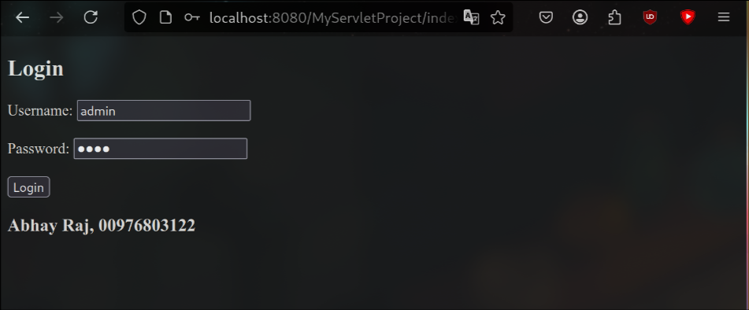
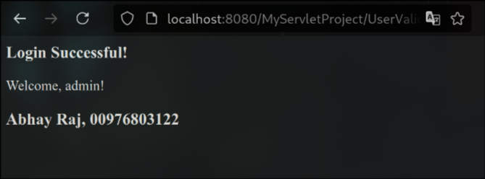
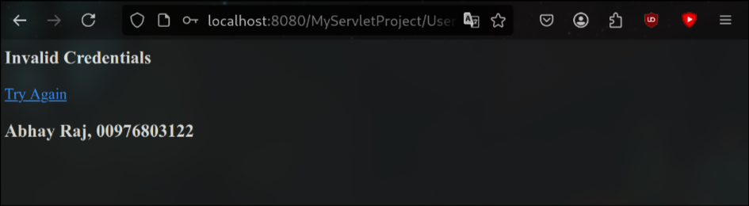

Program – 18

Aim: Write a Java program to set cookie Information using servlet.

Code:

/usr/share/tomcat8/webapps/CookieExample/WEB-INF/classes/SetCookieServlet.java

import java.io.IOException;
import java.io.PrintWriter;
import javax.servlet.ServletException;
import javax.servlet.annotation.WebServlet;
import javax.servlet.http.Cookie;
import javax.servlet.http.HttpServlet;
import javax.servlet.http.HttpServletRequest;
import javax.servlet.http.HttpServletResponse;

@WebServlet("/SetCookieServlet")
public class SetCookieServlet extends HttpServlet {
protected void doGet(HttpServletRequest request, HttpServletResponse response)
throws ServletException, IOException {
response.setContentType("text/html");
PrintWriter out = response.getWriter();

Cookie userCookie = new Cookie("username", "AdminUser");
userCookie.setMaxAge(60 * 60 * 24); // 1 day

response.addCookie(userCookie);

out.println("<h3>Cookie 'username' has been set!</h3>");
out.println("<a href='GetCookieServlet'>Click here to retrieve the cookie</a>");
out.println("<h3>Abhay Raj, 00976803122</h3>");
}
}

/usr/share/tomcat8/webapps/CookieExample/WEB-INF/classes/GetCookieServlet.java

import java.io.IOException;
import java.io.PrintWriter;
import javax.servlet.ServletException;
import javax.servlet.annotation.WebServlet;
import javax.servlet.http.Cookie;
import javax.servlet.http.HttpServlet;
import javax.servlet.http.HttpServletRequest;
import javax.servlet.http.HttpServletResponse;

@WebServlet("/GetCookieServlet")
public class GetCookieServlet extends HttpServlet {
protected void doGet(HttpServletRequest request, HttpServletResponse response)
throws ServletException, IOException {
response.setContentType("text/html");
PrintWriter out = response.getWriter();
Cookie[] cookies = request.getCookies();
if (cookies != null) {
for (Cookie cookie : cookies) {
if (cookie.getName().equals("username")) {
out.println("<h3>Stored Cookie Value: " + cookie.getValue() + "</h3>");
out.println("<h3>Abhay Raj, 00976803122</h3>");
}
}
} else {
out.println("<h3>No cookies found!</h3>");
}
}
}

Output:

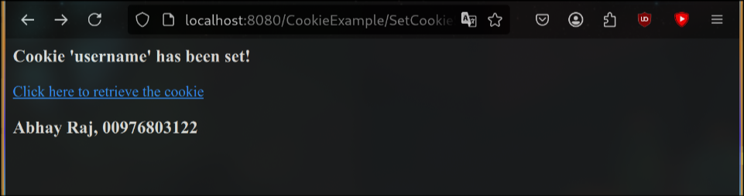
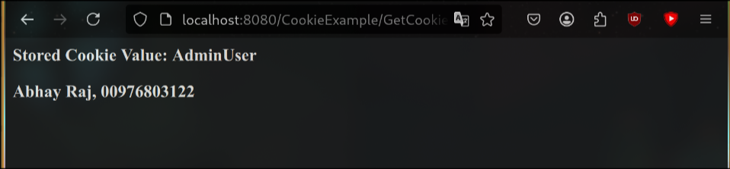

Program – 19

Aim: Write a Java program to insert data into a table using JSP.

Code:

//index.jsp

<html>
<head><title>User Form</title></head>
<body>
<h2>User Registration Form</h2>
<form action="submit.jsp" method="post">
Name: <input type="text" name="name" required><br><br>
Email: <input type="email" name="email" required><br><br>
<input type="submit" value="Submit">
</form>
<h3>Abhay Raj, 00976803122</h3>
</body>
</html>

//submit.jsp

<%@ page import="java.sql.*" %>
<%
String name = request.getParameter("name");
String email = request.getParameter("email");

// Simple validation
if (name == null || name.trim().isEmpty() || email == null || !email.contains("@")) {
%>
<h3>Invalid data. Please go back and try again.</h3>
<h3>Abhay Raj, 00976803122</h3>
<%
} else {
try {
Class.forName("com.mysql.cj.jdbc.Driver");
Connection con = DriverManager.getConnection(
"jdbc:mysql://localhost:3306/jsp_db", "root", "your_password");

PreparedStatement ps = con.prepareStatement("INSERT INTO users(name, email) VALUES (?, ?)");
ps.setString(1, name);
ps.setString(2, email);
int i = ps.executeUpdate();

if(i > 0){
%>
<h3>Data inserted successfully!</h3>
<h3>Abhay Raj, 00976803122</h3>
<%
} else {
%>
<h3>Insertion failed.</h3>
<%
}

con.close();
} catch(Exception e){
%>
<h3>Error: <%= e.getMessage() %></h3>
<%
}
}
%>

Output:

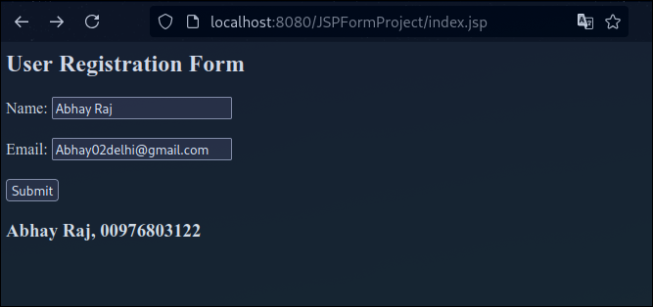

Abhay Raj, 00976803122
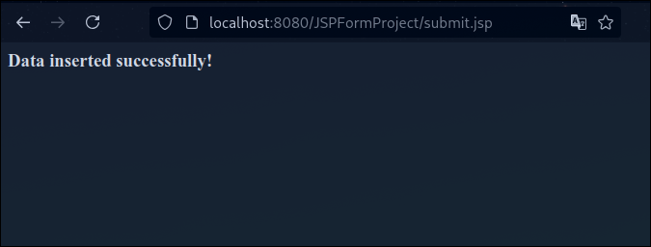

MariaDB [jsp_db]> SELECT * FROM users;
+----+-----------+------------------------+
| id | name | email |
+----+-----------+------------------------+
| 1 | Abhay Raj | Abhay02delhi@gmail.com |
+----+-----------+------------------------+
1 row in set (0.000 sec)

MariaDB [jsp_db]> Abhay Raj, 00976803122
Program – 20

Aim: Write JSP program to implement form data validation. complete steps in arch linux

Code:

//form.jsp

<%@ page language="java" contentType="text/html" pageEncoding="UTF-8"%>
<!DOCTYPE html>
<html>
<head>
<title>Form Validation</title>
</head>
<body>
<h2>User Form</h2>
<form action="submit.jsp" method="post">
Name: <input type="text" name="name" required><br><br>
Email: <input type="email" name="email" required><br><br>
<input type="submit" value="Submit">
</form>
<h3>Abhay Raj, 00976803122</h3>
</body>
</html>

//submit.jsp

<%@ page language="java" contentType="text/html; charset=UTF-8"%>
<%
String name = request.getParameter("name");
String email = request.getParameter("email");
boolean valid = true;

if(name == null || name.trim().equals("")) {
out.println("Name is required.<br>");
valid = false;
}

if(email == null || !email.matches("^[\\w.-]+@[\\w.-]+\\.[a-zA-Z]{2,6}$")) {
out.println("Invalid email format.<br>");
valid = false;
}

if(valid) {
%>
<h2>Form Submitted Successfully!</h2>
<p>Name: <%= name %></p>
<p>Email: <%= email %></p>
<h3>Abhay Raj, 00976803122</h3>
<%
}
%>

//WEB-INF/web.xml

<web-app>
<welcome-file-list>
<welcome-file>form.jsp</welcome-file>
</welcome-file-list>
</web-app>

Output:
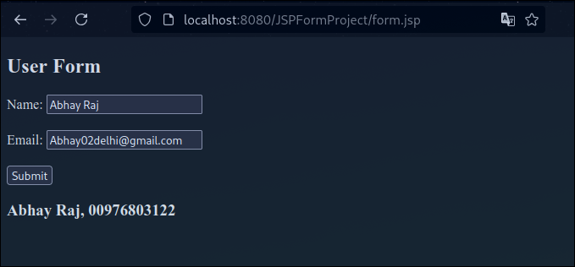

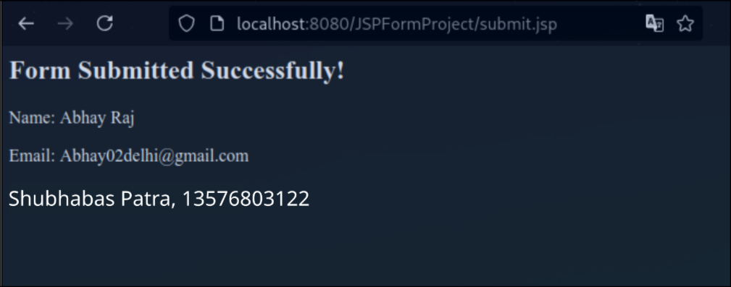
Program – 21

Aim: Write a Java program to demonstrate Remote Method Invocation (RMI) by creating a simple calculator application.

Code:

//Calculator.java

import java.rmi.Remote;
import java.rmi.RemoteException;

public interface Calculator extends Remote {
int add(int a, int b) throws RemoteException;
}

//CalculatorImpl.java

import java.rmi.Naming;
import java.rmi.RemoteException;
import java.rmi.server.UnicastRemoteObject;

public class CalculatorImpl extends UnicastRemoteObject implements Calculator {

public CalculatorImpl() throws RemoteException {
super();
}

public int add(int a, int b) throws RemoteException {
return a + b;
}

public static void main(String[] args) {
try {
CalculatorImpl obj = new CalculatorImpl();
Naming.rebind("CalculatorService", obj);
System.out.println("Calculator Server is ready.");
System.out.println("Abhay Raj, 00976803122");
} catch (Exception e) {
System.out.println("Calculator Server failed: " + e);
}
}
}

//CalculatorClient.java

import java.rmi.Naming;

public class CalculatorClient {
public static void main(String[] args) {
try {
Calculator calc = (Calculator) Naming.lookup("rmi://localhost/CalculatorService");
int result = calc.add(10, 20);
System.out.println("Result of addition: " + result);
System.out.println("Abhay Raj, 00976803122");

} catch (Exception e) {
System.out.println("Calculator Client failed: " + e);
}
}
}

Output:

//java CalculatorImpl

Calculator Server is ready.
Abhay Raj, 00976803122

//java CalculatorClient

Result of addition: 30
Abhay Raj, 00976803122

